In the diagram below, the cube is inscribed in the sphere with center O. If the radius of the sphere is 6 cm, determine the volume of the cube.

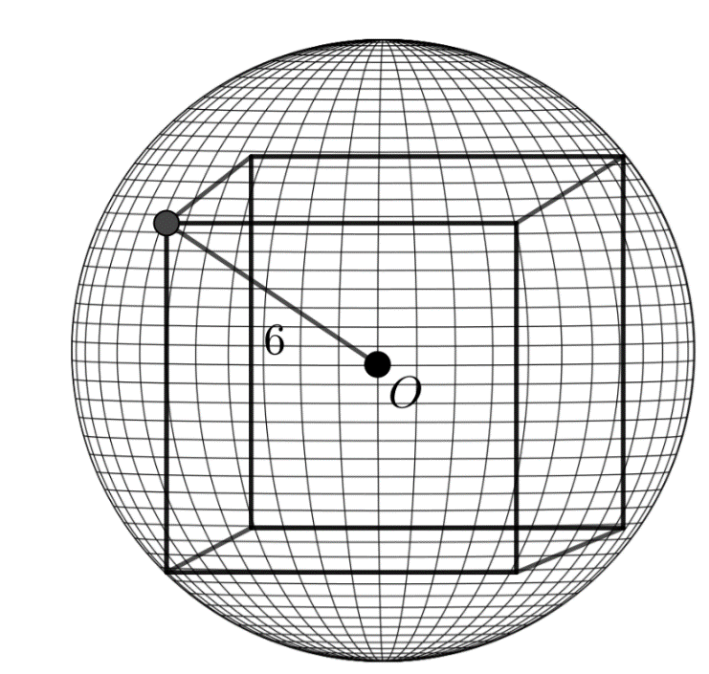

It can be assumed *d* = 12, as $2r=d$. Because, the cube is inscribed on the inside of the circle the distance from the closest side’s top left vertex to the furthest side’s bottom right vertex is also 12. This diagonal is directly related to the side length of the cube. We know that the diagonal from the bottom front right corner and the bottom left back corner can be determined using Pythagoras as s2 + s2 = d2, therefore $\sqrt{2s^{2}}= d$. Then using Pythagoras again the cubes diagonal can be calculated using the diagonal of one of the cubes faces and the side length. If a is the side length of one of the cubes faces then, a2 + s2 = d2, we can also substitute the value of a that we determine earlier leaving 2s2 + s2 = d2, Therefore $s=\frac{\sqrt{3}d}{3}$. Combining the formulas for the volume of a cube, and the formula for the side length of a cube given the cubes diagonal, we can determine that ${\left(\frac{\sqrt{3}d}{3}\right)}^{3}=v$, or $\frac{d^{3}}{3\sqrt{3}}=v$ can be used to solve for the volume of any cube given the cubes diagonal. In the example given above $\frac{{12}^{3}}{3\sqrt{3}}=v=332.55 cm^{3}$.